AICTE | IBM SkillsBuild
Data Analytics with AI Internship 2026 | BharatCares
PROJECT REPORT
Customer Churn Prediction using Data Analytics and AI
Submitted by: OMKAR PANDEY
B.Tech – Computer Science and Engineering
Date: 24/09/2026

Abstract
Customer churn means a customer stops using a company's service. In telecom, keeping an old customer costs much less than finding a new one, so predicting churn early is valuable. This project uses the IBM Telco Customer Churn dataset (7,043 customers) to find why customers leave and to predict who is likely to leave next.
The data was cleaned, explored with charts, and used to train three machine learning models: Logistic Regression, Random Forest and Gradient Boosting. Random Forest gave the best balance between catching churners and avoiding false alarms (recall 0.79, ROC-AUC 0.84). The project also shows that churn is highest for month-to-month contracts, new customers, fiber optic users and electronic check payers. Based on these findings, six practical actions are recommended.
1. Introduction
Telecom is a competitive market. Customers can change providers easily, and every lost customer means lost monthly income. Companies therefore want to know two things: which customers are about to leave, and what can be done to keep them.
Data analytics and AI help answer both. Analytics finds patterns in past behavior. AI models use those patterns to give each customer a churn risk score.
2. Problem Statement
About one in four customers in the dataset leaves the company. The company does not know clearly which customers are at risk or what causes them to leave. This project aims to find the main causes of churn and build a model that predicts churn.
3. Objectives
- Clean and understand the customer data.
- Find the main factors linked to churn using charts and simple statistics.
- Build and compare three machine learning models.
- Pick the most useful model and create a risk ranking of customers.
- Give clear business recommendations to reduce churn.
4. Dataset
The IBM Telco Customer Churn dataset is a public dataset shared by IBM on GitHub. Each row is one customer.
Item | Detail
Source | github.com/IBM/telco-customer-churn-on-icp4d
Rows | 7,043 customers (7,032 after cleaning)
Columns | 21
Target | Churn (Yes / No)
Customer profile | gender, senior citizen, partner, dependents
Services | phone, multiple lines, internet, security, backup, protection, tech support, streaming
Account | tenure, contract, paperless billing, payment method, monthly charges, total charges

5. Tools and Technologies
- Python 3 for all code
- pandas and numpy for data handling
- matplotlib and seaborn for charts
- scikit-learn for machine learning
- Jupyter Notebook for running and showing the work
6. Methodology
6.1 Data cleaning
- TotalCharges was stored as text. It was converted to numbers.
- 11 rows had no TotalCharges. All 11 were new customers with tenure of 0 months who had not been billed yet. They are only 0.16% of the data, so they were removed.
- customerID was removed because it is only a label.
- No duplicate rows were found.
6.2 Data preparation
- Numbers (tenure, MonthlyCharges, TotalCharges) were scaled to a similar range.
- Text columns were converted to numbers using one-hot encoding.
- Data was split 80% for training and 20% for testing. The split kept the same churn ratio (26.6%) in both parts.
6.3 Models
- Logistic Regression: simple and easy to explain.
- Random Forest: combines many decision trees.
- Gradient Boosting: builds trees one after another, each fixing the earlier mistakes.
Because only about a quarter of customers churn, the models were told to give extra weight to churners (class_weight = balanced), where supported. 5-fold cross-validation was also used on the training data to check that results are stable.
7. Exploratory Data Analysis
7.1 Churn rate
26.6% of customers churned. The data is imbalanced, so accuracy alone can give a false sense of success. A model that always says 'no churn' would be right about 73% of the time, but it would be useless for the business. For this reason recall, F1 and ROC-AUC are also used.
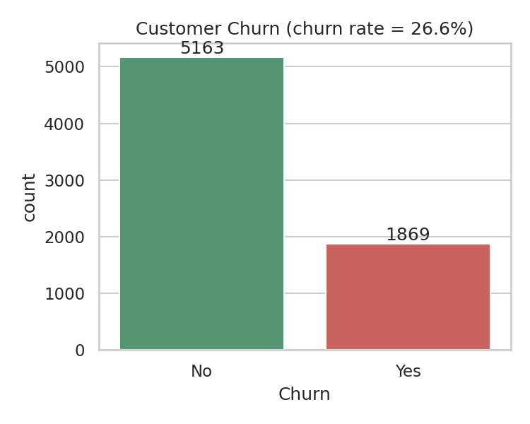
Figure 1: Number of customers who stayed and churned
7.2 Contract type
Contract type has the strongest link with churn.
Contract | Churn rate
Month-to-month | 42.7%
One year | 11.3%
Two year | 2.8%
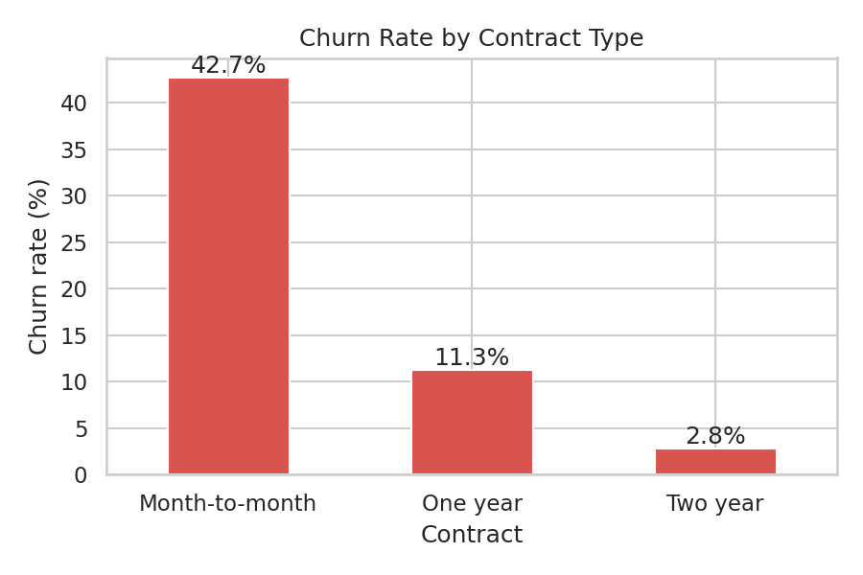
Figure 2: Churn rate by contract type
7.3 Tenure
Customers who churn leave early. The median tenure of churned customers is 10 months, compared with 38 months for customers who stayed.
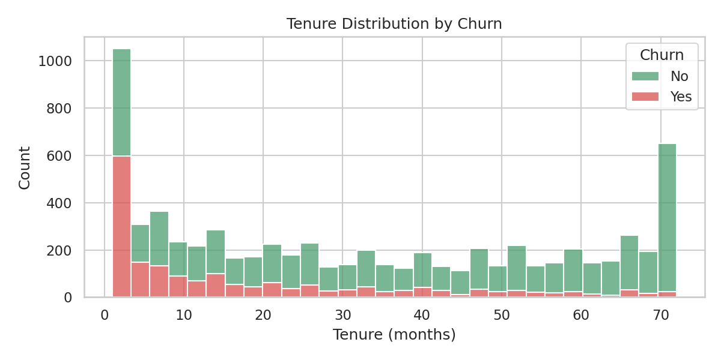
Figure 3: Tenure by churn
7.4 Monthly charges
Churned customers pay more per month. Their median bill is 79.65, compared with 64.45 for customers who stayed.
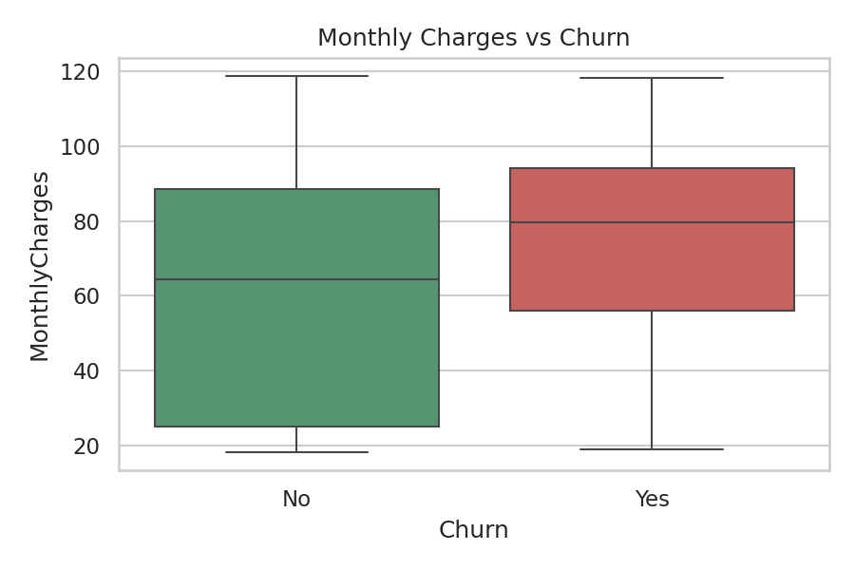
Figure 4: Monthly charges by churn
7.5 Internet service and payment method
- Fiber optic customers churn at 41.9%, DSL at 19.0%, and customers with no internet at 7.4%.
- Electronic check payers churn at 45.3%. Customers on automatic payment (credit card or bank transfer) churn at only 15% to 17%.
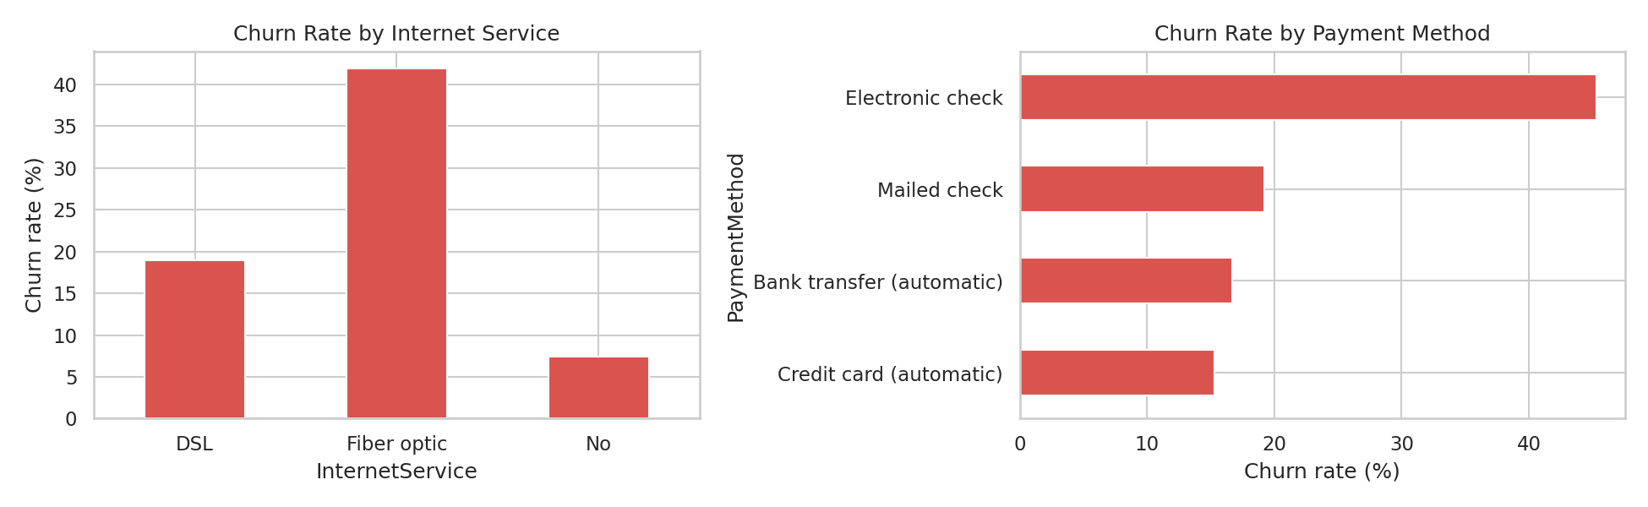
Figure 5: Churn by internet service and payment method
7.6 Support services
Customers who have support services churn far less than those who do not.
Service | Has service | No service
Online Security | 14.6% | 41.8%
Tech Support | 15.2% | 41.6%
Online Backup | 21.6% | 39.9%
Device Protection | 22.5% | 39.1%
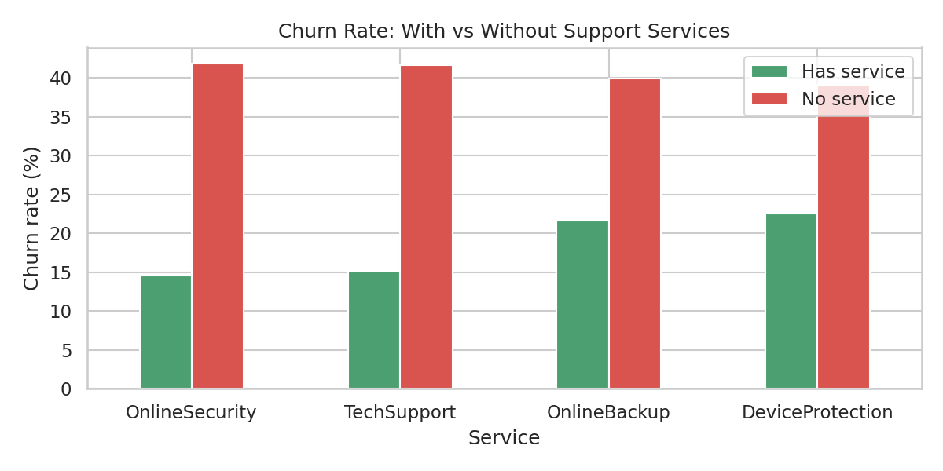
Figure 6: Churn with and without support services
Note: these are links, not proof. Customers who buy security and support may also be more committed customers in general.
7.7 Correlation
Tenure has a negative link with churn. TotalCharges is strongly tied to tenure, as expected, because it is roughly tenure multiplied by monthly price.
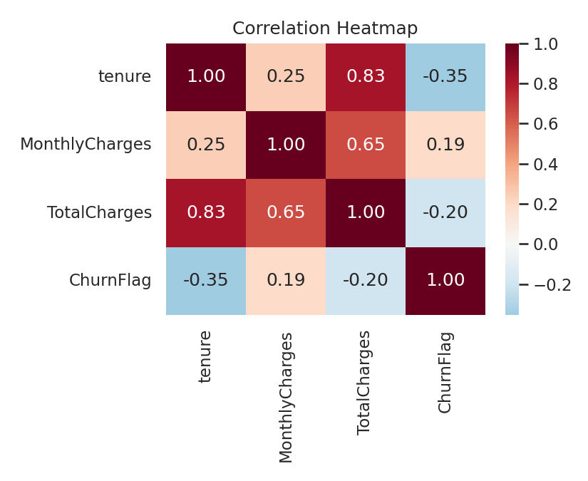
Figure 7: Correlation heatmap
8. Model Results
All models were tested on 1,407 customers that they had never seen.
Model | Accuracy | Precision | Recall | F1 | ROC-AUC
Logistic Regression | 0.726 | 0.491 | 0.797 | 0.608 | 0.835
Random Forest | 0.751 | 0.520 | 0.789 | 0.627 | 0.835
Gradient Boosting | 0.796 | 0.641 | 0.529 | 0.580 | 0.839

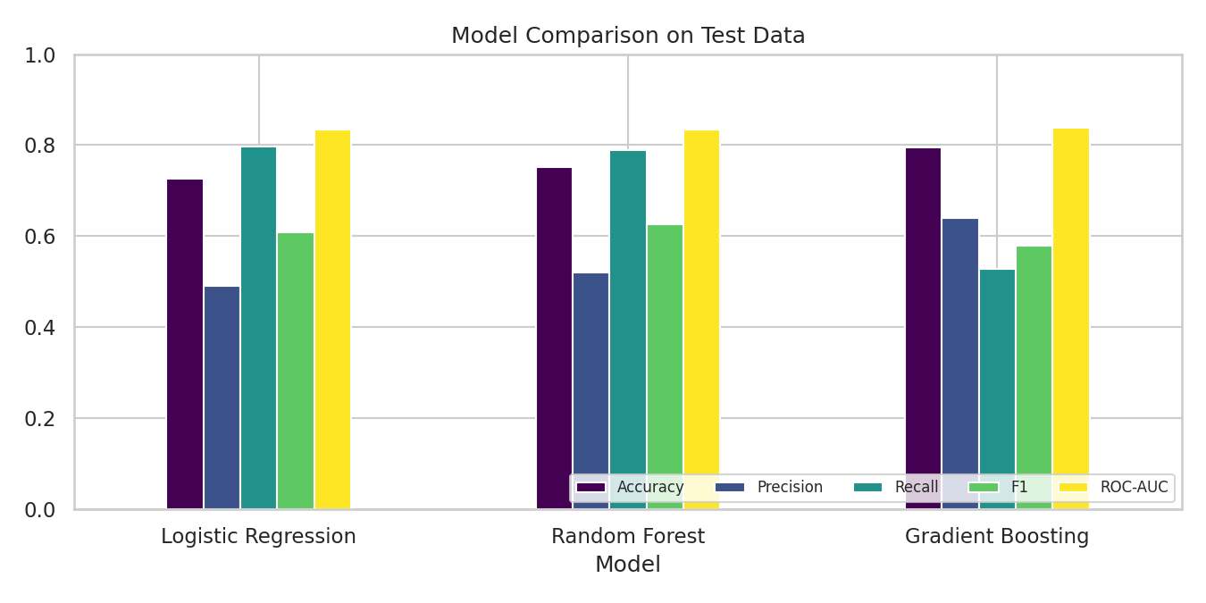
Figure 8: Model comparison on test data
8.1 Choosing the best model
- All three models have almost the same ROC-AUC (about 0.84), so this score cannot separate them.
- Gradient Boosting has the highest accuracy, but it finds only 53% of the customers who leave.
- Logistic Regression and Random Forest find about 79% of churners. Random Forest has the better F1 score, so it was chosen.
- The cost of losing a customer is usually higher than the cost of a retention call to someone who would have stayed. This is why recall was given more weight than accuracy.
Random Forest details: of the customers who really churned, 79% were caught. When it predicts churn, it is right 52% of the time. This means about half of the alerts are false alarms, which is an acceptable price if the retention offer is cheap.
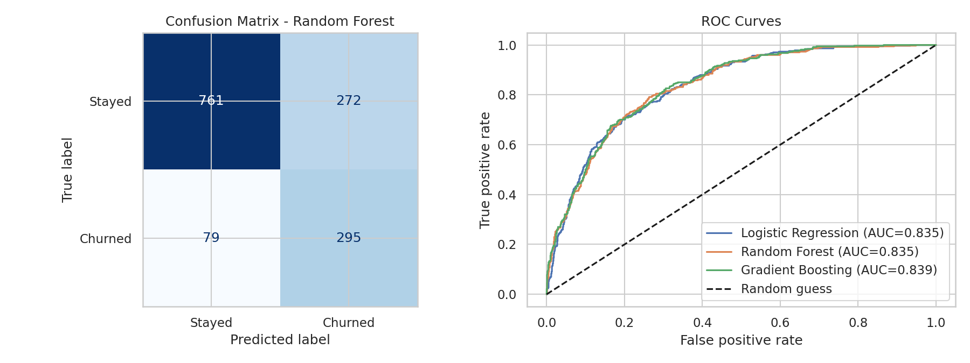
Figure 9: Confusion matrix (left) and ROC curves (right)
8.2 Most important factors
The top factors used by the Random Forest are: month-to-month contract, tenure, total charges, two-year contract, no online security, monthly charges, no tech support, fiber optic internet and electronic check payment. This matches what the charts showed.
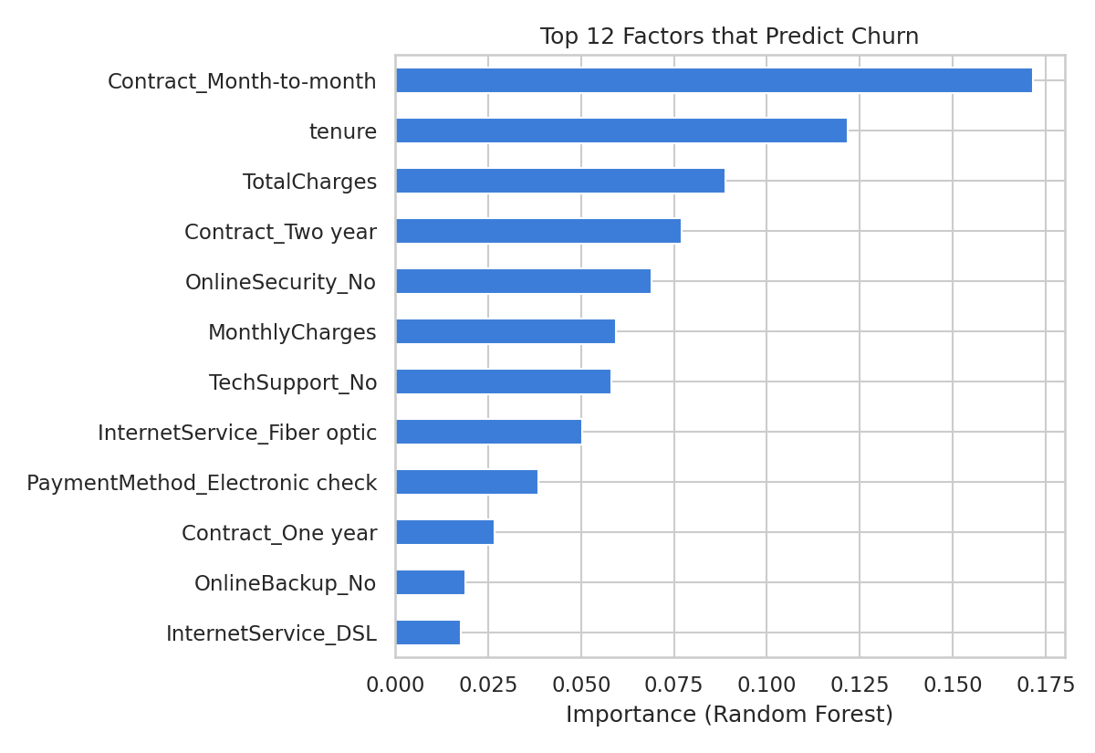
Figure 10: Top 12 factors that predict churn
8.3 Risk groups
Customers in the test data were placed into groups by the model's churn probability. The groups separate real churn well:
Risk group | Customers | Actual churn rate
Low (below 40%) | 727 | 8.1%
Medium (40% to 70%) | 371 | 32.1%
High (above 70%) | 309 | 63.4%

The High group churns almost eight times more than the Low group. The retention team can start with this High group.
9. Recommendations
- Move month-to-month customers to 1-year or 2-year plans with a small discount.
- Focus on the first 12 months: welcome call, check-in after month 1 and month 3.
- Offer online security and tech support free or at low cost for a trial period.
- Review price and service quality for fiber optic customers.
- Encourage automatic payment instead of electronic check.
- Use the model every month to rank customers and contact the High risk group first.
10. Limitations
- The data is one snapshot. It does not show how a customer's behavior changes over time.
- The findings show links, not proven causes. An A/B test (offer a deal to half of the high-risk customers and compare) is needed to prove what works.
- No cost or profit data is included, so the exact money saved cannot be calculated.
- Models were not deeply tuned. Results could improve with more tuning.
- The data comes from one company and may not match other markets.
11. Future Work
- Tune models and try XGBoost or LightGBM.
- Pick the alert cut-off using real retention cost and customer value.
- Add time-based data such as recent complaints, call logs and usage drops.
- Build a simple dashboard so managers can see risk scores.
12. Conclusion
This project shows that customer churn can be explained and predicted using data. Contract type, tenure, internet service, payment method and support services are the main drivers. A Random Forest model can catch about 79% of churners, and its risk groups clearly separate customers who will stay from customers who will leave. If the company acts on these findings, it can reduce churn and protect its income.
References
- IBM Telco Customer Churn dataset: https://github.com/IBM/telco-customer-churn-on-icp4d
- scikit-learn documentation: https://scikit-learn.org
- pandas documentation: https://pandas.pydata.org
- seaborn documentation: https://seaborn.pydata.org

